Lab: Functions
Please, submit your source code solutions for the described problems to the Judge System.

Absolute Values
Write a program that receives a sequence of numbers, separated by a single space, and prints their absolute value as a list. Use abs().

Example
Input | Output
1 2.5 -3 -4.5 | [1.0, 2.5, 3.0, 4.5]
-0 1 10 -6.66 | [0.0, 1.0, 10.0, 6.66]

Grades
You will receive a float number (between 2.0 and 6.0 inclusive), representing a grade, as input from the console. Write a function that receives this value and returns the corresponding grade in words.
Read the input from the console and print the function's result.
Submit your code to the Judge system, including the input and print statements, together with the function.
- 2.00 – 2.99 - "Fail"
- 3.00 – 3.49 - "Poor"
- 3.50 – 4.49 - "Good"
- 4.50 – 5.49 - "Very Good"
- 5.50 – 6.00 - "Excellent"

Examples
Input | Output
3.33 | Poor
4.50 | Very Good
2.99 | Fail

Hints
- Read the grade from the console:
- Then, create a function and make an if statement for each case:
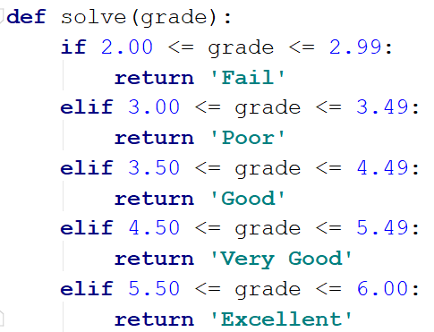
- Pass the input grade to the function:

Calculations
Create a function that receives three parameters, calculates a result depending on the given operator, and returns it. Print the result of the function.
The input comes as three parameters – an operator as a string and two integer numbers. The operator can be one of the following: "multiply", "divide", "add", and "subtract".

Example
Input | Output
subtract  5  4 | 1
divide  8  4 | 2

Hints
- Read the input data from the console:
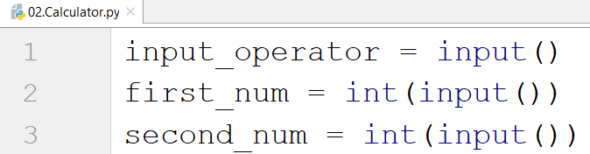
- Then, create the function and make an if statement for each case:
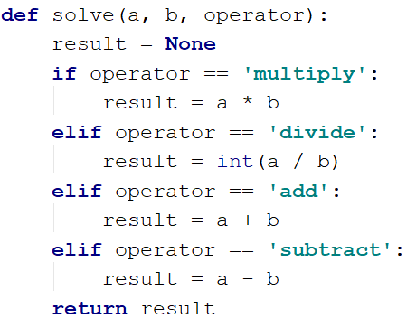
- Print the result by calling the function and passing the given parameters.

Repeat String
Write a function that receives a string and a counter n. The function should return a new string – the result of repeating the old string n times. Print the result of the function. Try using lambda.

Examples
Input | Output
abc  3 | abcabcabc
String  2 | StringString

Hints
- Read the input data:
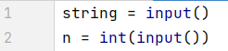
- Create the function:
- Print the result:
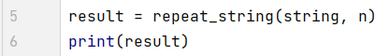

Orders
Write a function that calculates the total price of an order and returns it. The function should receive one of the following products: "coffee", "coke", "water", or "snacks", and a quantity of the product. The prices for a single piece of each product are:
- coffee - 1.50
- water - 1.00
- coke - 1.40
- snacks - 2.00

Print the result formatted to the second decimal place.

Example
Input | Output
water  5 | 5.00
coffee  2 | 3.00

Calculate Rectangle Area
Create a function that calculates and returns the area of a rectangle by a given width and height. Print the result on the console.

Examples
Input | Output
3  4 | 12
6  2 | 12

Rounding
Write a program that rounds all the given numbers, separated by a single space, and prints the result as a list. Use round().

Example
Input | Output
1.0 2.5 3.0 4.5 | [1, 2, 3, 4]
2.56 1.9 -3.4 8.1 | [3, 2, -3, 8]

